1. Print your name five times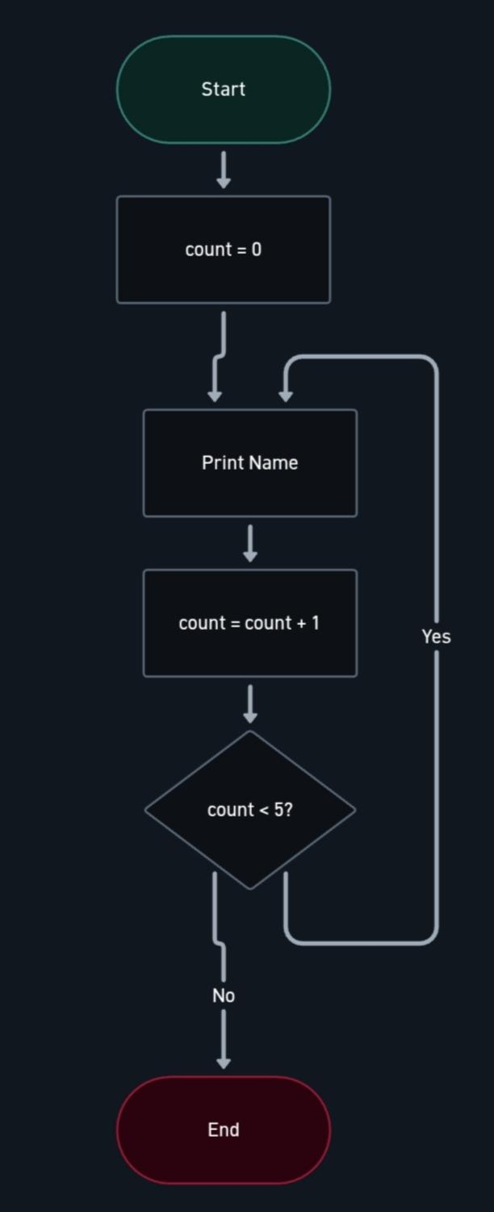

2. Swap two initialized values (a=10, b=5)
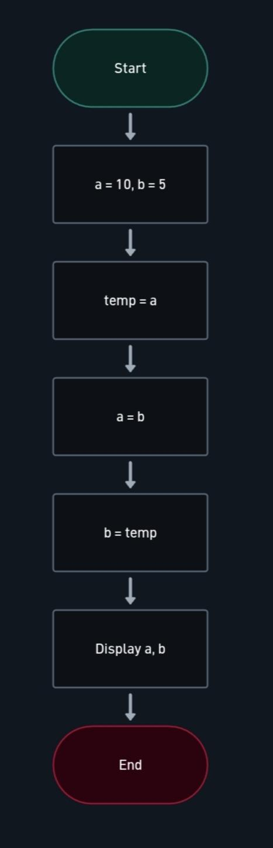

3. Compute sum, difference, product, and quotient
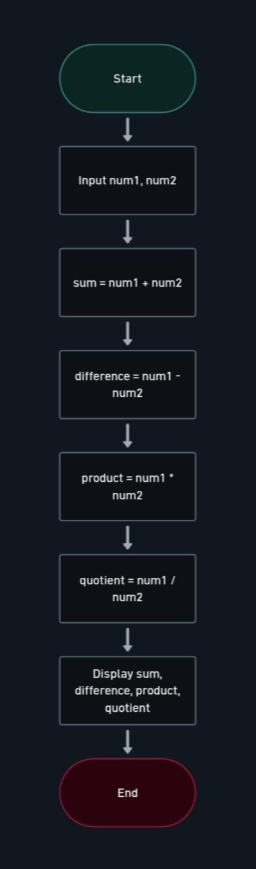

4. Convert Celsius to Fahrenheit


5. Compute Total Sales
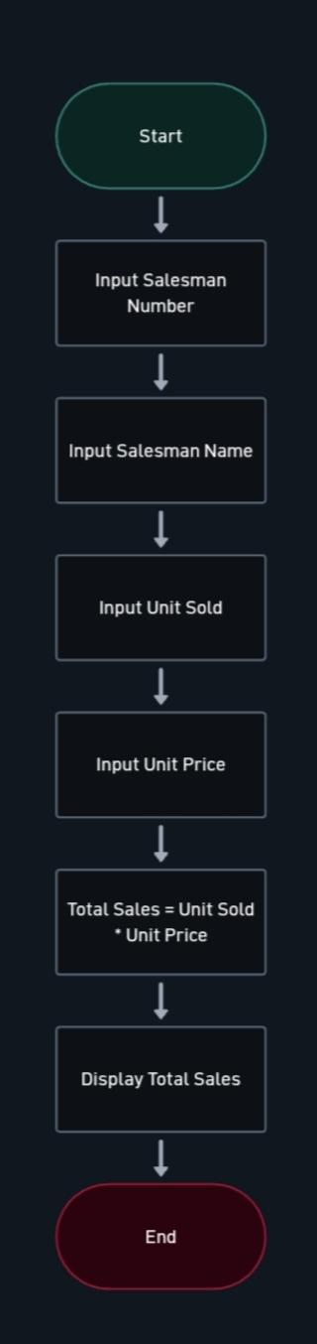

6. Compute Average Grade
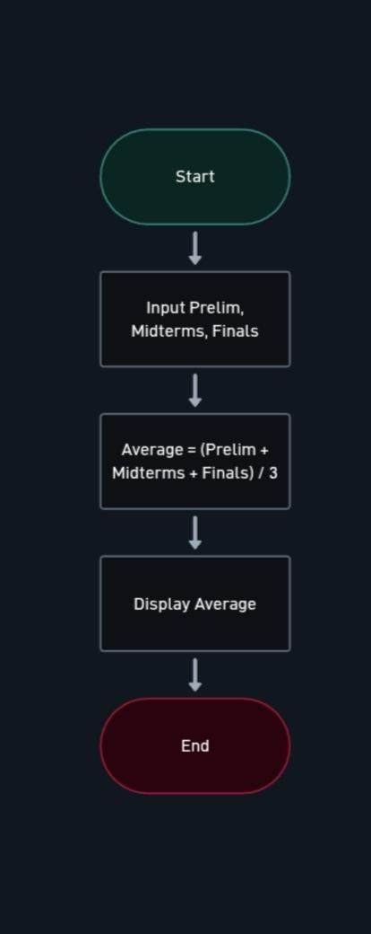

7. Compute Cube and Square of a Number
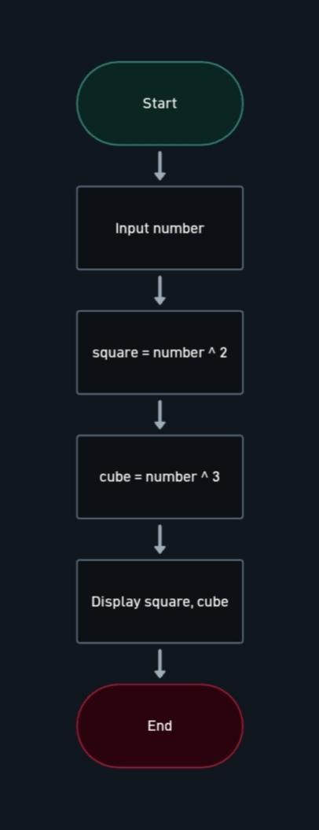

8. Compute Area and Perimeter of a Rectangle
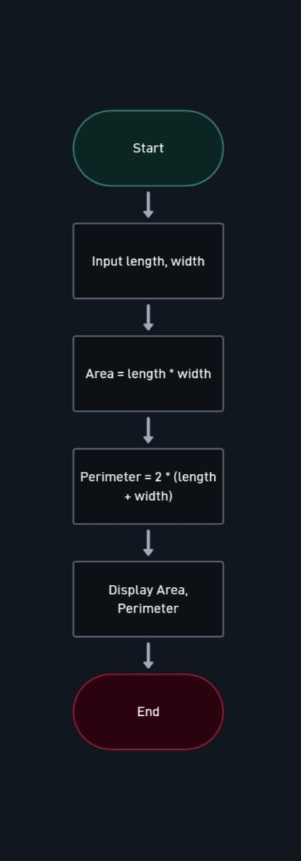

9. Compute Area and Circumference of a Circle

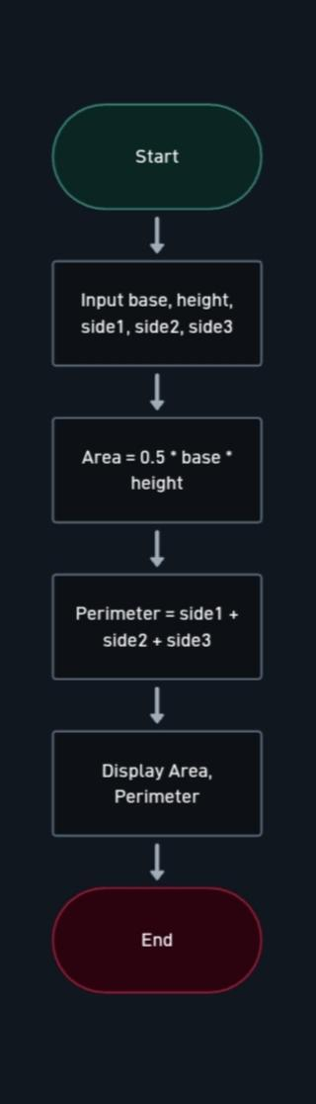

10. Compute Area and Perimeter of a Triangle
